## AI Based Diabetes Prediction System

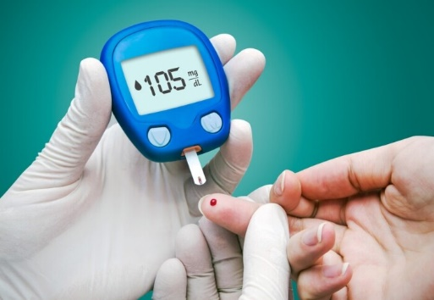

A software application or platform that utilizes artificial intelligence (AI) and machine learning techniques to analyze medical and demographic data of individuals and predict the likelihood of them developing diabetes in the future. This system provides early risk assessment and personalized preventive measures to help individuals manage and reduce their risk of diabetes.

**Data Collection:**

Gather a comprehensive dataset that includes medical and demographic information of individuals, such as age, gender, BMI (Body Mass Index), blood pressure, glucose levels, pregnancy, Skin thinkness,Insuline level and other relevant features.

Collect split up the data for age wise and BMI (Body Mass Index)level in asper dataset.

DATA LIST:

Gender : Female

No.of.Pregnancies : 0-17

Glucose :0-200mg/dL

BloodPressure :0-122 mm/Hg

SkinThickness :0-70 mm

Insulin :0-900pmol/L

BMI :0-70.0Kg/M^2

Age :21-70

|  |  |  |  |  |
| --- | --- | --- | --- | --- |
|  |  |  |  |  |

DESIGN MODELING

AI& ML algoriithms using modelings.

|  |  |  |  |  |  |  |  |  |  |  |
| --- | --- | --- | --- | --- | --- | --- | --- | --- | --- | --- |
|  |  |  |  | |  | | --- | |  | |  |  |  |  |  |
|  |  |  |  |  |  |  |  |  |  |
|  |  |  |  |  |  |  |  |  |  |
|  | INPUT | |  |  |  |  |  | OUTPUT | |
|  |  |  |  |  |  |  |  |  |
|  |  |  |  |  |  | MODEL |  |  |  |

**Input** :is collection of data in manual and instrument outputs

**Model :** modeling is implement on low level languages, medium level languages and

High level machine learning languages.

There use for data structures , syntaxes and iteration loops.

**Output:** requesting data confirmations.

**DATA ANALYSIS:**

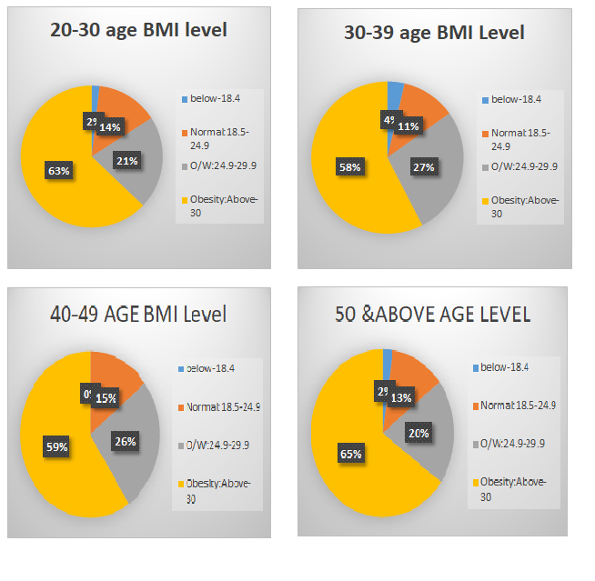

**DIGITAL GADGETS IN BLOOD PRESSURE**

# POCT DIGITAL BLOOD PRESSURE MONITOR WITH

# GLUCOMETER KIT

**SYSTEM THINKING**

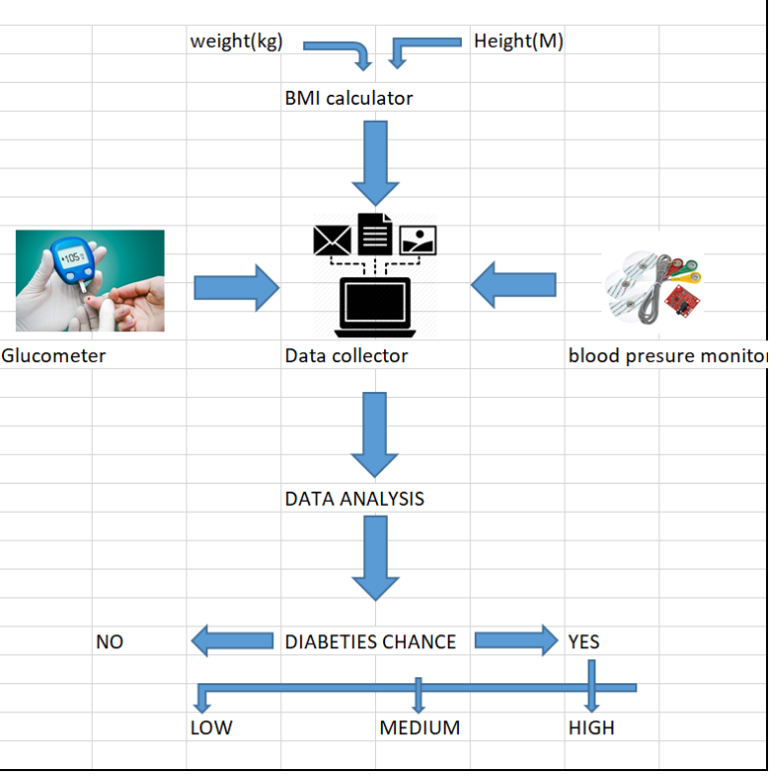

**AI SYSTEM DESIGN USING ML ALGORITHM:**

